**Document Revision History**

*(The following table lists revisions made to this document, tracked by publication version.)*

|  |  |  |  |
| --- | --- | --- | --- |
| **#.#** | **Sections Modified and Description** | **Date** | **Author** |
| - | ECM500000364077: Initial release in SAP | 14.04.2020 | A. Elbasyouny |
|  |  |  |  |
|  |  |  |  |
|  |  |  |  |
|  |  |  |  |
|  |  |  |  |
|  |  |  |  |
|  |  |  |  |
|  |  |  |  |
|  |  |  |  |

**Table of Contents**

1.0 Purpose 3

2.0 Scope & Applicability 3

3.0 Terms, Definitions, Acronyms 4

4.0 Measuring Equipment and Material 5

5.0 Prerequisites 6

5.1 General 6

5.2 USIPxs and PC Configuration 6

6.0 Procedure 9

6.1 Login and connect 9

6.2 Certification measurements – Pulser Tests 12

6.3 Certification measurements – Amplifier Tests 16

6.4 Certification measurements – Final Steps 18

7.0 Loading measurement values 21

8.0 FAQs 22

9.0 References 27

10.0 Compliance Timeline 32

# Purpose

This work instruction describes the Quality testing procedure for certifying USIPxs Box. The Certification is done according to the acceptance criteria described in the SAP Technical Statement TS_0015556.

This work instruction is mandatory for all the Waygate Technologies locations that assemble USIPxs boxes.

This quality test shall be performed before the module is shipped to another location, or assembled into a testing machine in the same location.

This quality test shall also be performed before the Testing Machines leaves the manufacturing department.

This work instruction is also applicable for yearly re-certification of the USIPxs Boxes during the Service life cycle of the Testing Machine.

# Scope & Applicability

This process will be used for testing the following equipment:

|  |  |
| --- | --- |
| **SAP-Material number** | **Description** |
| USIPxs-E08L | Hector 8Ch Lemo (Essential Line) |

This process will be used by the following departments:

* Supply chain: End test after production of modules.
* Supply chain: As part of the testing machine validation process.
* Service: Re-Certification of electronic at customer site or in any Baker Hughes facility.

# Terms, Definitions, Acronyms

Refer to the [GE O&G QMS Lexicon](http://supportcentral.ge.com/@lexicon) for standardized terms, definitions and acronyms. Terms may be repeated here for convenience; however, in the event of conflict, the GE O&G QMS Lexicon will take precedence.

dB - Decibel

Hz - Hertz

kHz - Kilohertz

MHz - Megahertz

µs - Micro seconds

ns - Nano seconds

V - Volt

Vpp - Volt peak-peak

Ω - Ohm

PRF - Pulse repetition frequency

Max - Maximum

Min - Minimum

mm - Millimeters

%SH - Percent screen height

f0 - Center frequency of frequency response curve

fl - -3dB point left of the center frequency of frequency response curve

fu - -3dB point right of the center frequency of frequency response curve

TOF - Time of flight

LAS - Large Amplitude Signal

SAS - Small Amplitude Signal

# Measuring Equipment and Material

* 350MHz bandwidth Oscilloscope
* Pulsed signal generator with external trigger capable of producing a gated burst of sinusoidal radio frequency signal with a minimum range of 0.1MHz to 25MHz
* Standard 50Ω attenuator with 0.1dB ±0.03dB steps. Necessary testers are listed with type and calibration status.
* Gigabit network switch with min. 8 slots
* 5x Network cables long enough to connect the measurement equipment to the network switch
* 1 Network cable long enough to connect the laptop to the network switch
* 1 Network cable long enough to connect the TM network switch to the network switch were the measuring equipment and laptop are connected
* 4x 1 meter long, PE-50Ω double screen coaxial cable (RG-223/U type) with male BNC connectors on both sides
* 2x BNC T-Connectors
* 1x 1 meter long, PE-50Ω double screen coaxial cable (RG-223/U type) with one ferrite cores (part No. TRM-31-20-15E-WE) to connect the attenuator.
* Tyco-to-2xSamtec Adapter (110N2027)
* Adapter SAMTEC 64 X 93.1 Ω (SAP No. 110N3613)
* 100:1 divider, 1 meter long coaxial cable with a 50Ω through impedance (SAP No. 0036913)
* Trigger-Adapter (SAP No. 110N2752)

# Prerequisites

## General



Wherever the test is being performed, the field service engineer must be sure to comply with all applicable Waygate Technologies and/or customer safety procedures.



Before beginning the certification ensure that ALL measurement equipment that will be used during the certification is calibrated and that the calibration certificates for the devices are not expired. The certification will NOT be valid if any one of the measurement devices is not calibrated.



Ensure that you have the latest version of the Certification System software installed on your certification PC. If you are not sure, contact the Huerth Service Department administration



To avoid potential IP address conflicts, be sure the testing machine’s operation PC is either switched off or not connected to the testing machine during the certification.

## USIPxs and PC Configuration

* Copy the SystemConfig.xml file from the customer computer (usually found under C:\GEIT\PC-Prog\). Paste the file into the certification laptop under the folder where the TCPIPSERV64.exe is started (C:\GEIT\NGE). Do not change the name of the file.
* Connect the certification laptop to the network switch of the testing machine where the Hector electronics are connected. Make sure you are using a 1 Gigabit network adapter.
* Switch off all USIPxs boxes of the testing machine.
* Connect the trigger adopter to the ‘’I/O’’ connecter of the box being certified
* Start the tftpd32 service by right clicking the restart_tftp.bat file under C:\Program Files\GEIT\Cert-System\Script\ (or the desktop icon) and running it as administrator.
* Ensure that the IP address for the USIPxs System is included in the settings for the network adapter

IP: 192.168.200.200

Subnet mask: 255.255.240.0

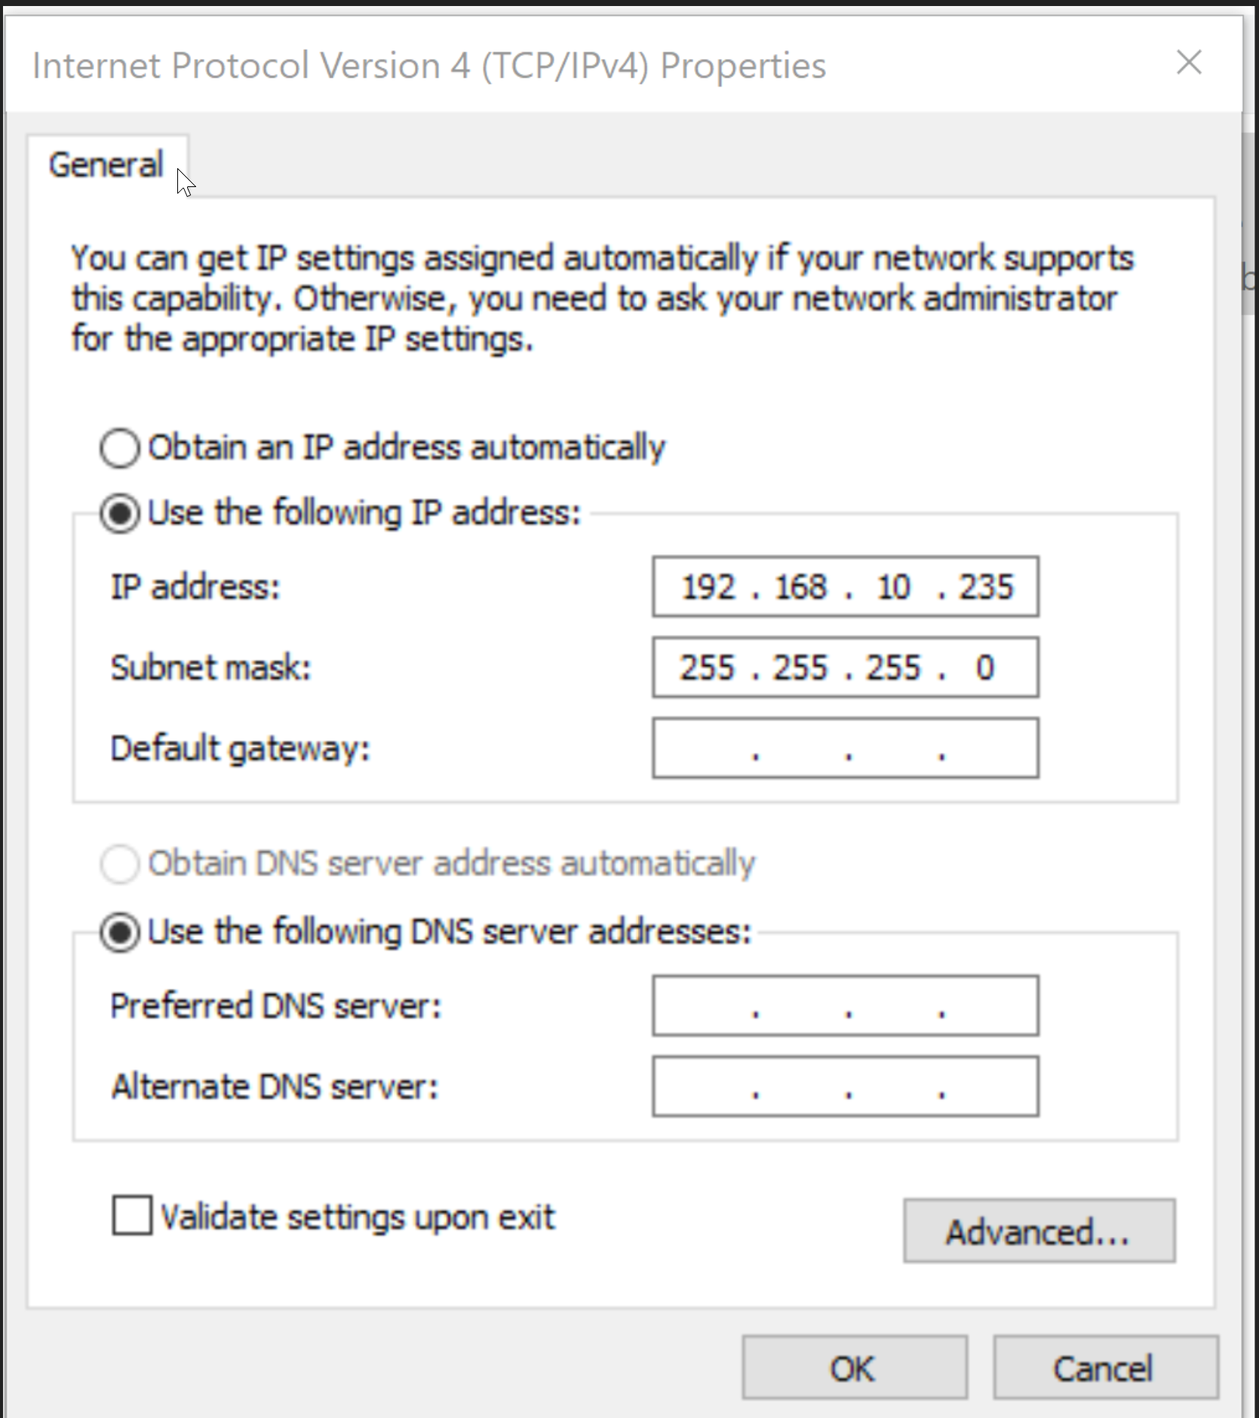 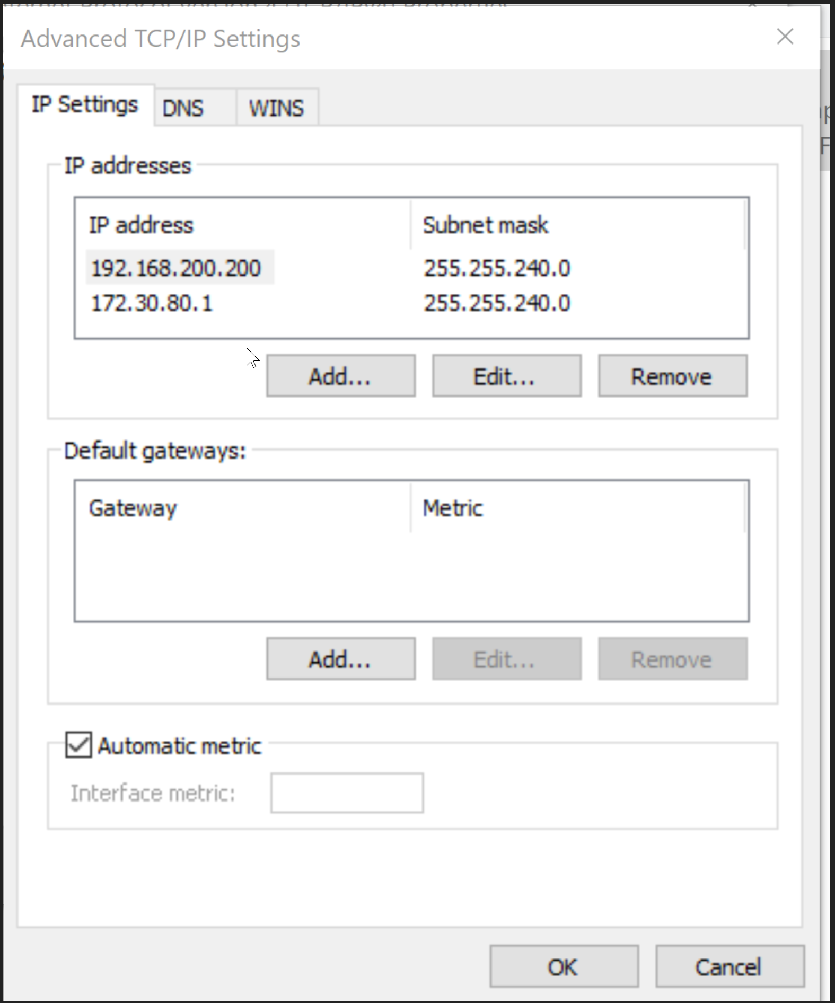

Basic static address of NIC Additional addresses in Advanced

* Switch all USIPxs boxes back on, start the TCPIPSERV64.exe from the desktop icon and wait until the T icon of the program turns green. Be patient – it might take some time.
* 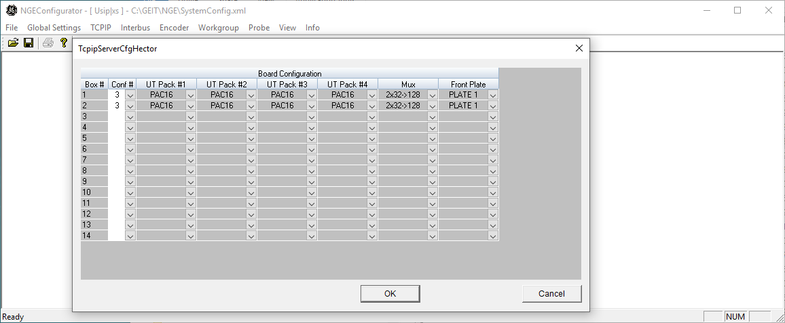If the TCPIP server does not connect, check all cables, ensure the SystemsSetting.ini has been copied to the correct location, and open the NGEConfigurators64 to confirm the correct configuration.
* Turn on all measurement devices and connect them to the certification laptop via Ethernet cables through the network switch. Ensure that all of the measurement equipment is listed in NI-MAX (National Instruments Measurement & Automation Explorer) program under network devices and that they don’t have an exclamation or X symbol.

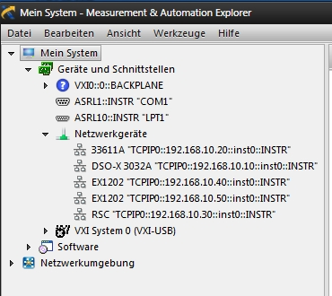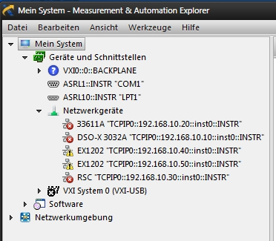

Normal startup in NI-MAX 3 devices listed but not connected

* If the devices are listed but not connected:
  + Ensure the devices are powered on
  + Check the CAT5 cables and the modem
  + Restart the PC and the measurement devices
* If the devices are not listed:
  + Select “Network Devices” under Devices and Interfaces
  + On the right panel in NI-MAX, select “Add Network Device” and then “VISA TCP/IP Resource”
  + Select “Manual Entry of LAN Instrument” and click next
  + Write the IP address of the equipment under “Hostname or IP address” (see above diagram for correct settings)
  + Write inst0 (in small case, the last character is a zero) and click Validate
  + If you see an error message, rectify the IP address of the equipment or the cable connection. If there is a successful connection click on “Finish”.

# Procedure

## Login and connect

* Start the Certification software by double clicking the CertSystem desktop icon
* Type in your SSO and select the legal entity performing the certification

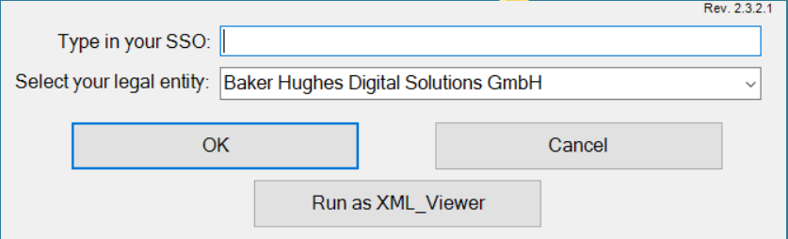

The SSO will be saved in the database and used to populate the name of the person that performed the certification on the certificate of calibration. It is very important to type a valid SSO.

The selected legal entity will be saved in the database and will be presented on the certificate of calibration. Please select the right one.

* Enter a name for the data folder that will be generated under C:\ProgramFiles\ Waygate Technologies \ Cert.-System \ Mess_Dat. The files containing the measured values collected during the certification will be stored in this folder.

Choose a folder name that is indicative of the event. For example: machine number

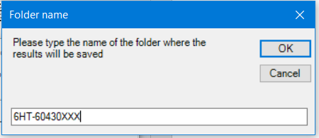

* After entering the folder name click OK and click OK again to confirm the following dialogue. If the folder name that you have selected already exists the dialogue will ask if you want to import the data or overwrite it. Decide carefully.

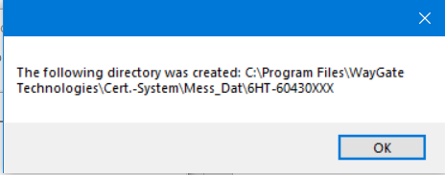

* On the following dialogue, select Hector(USIPxs)

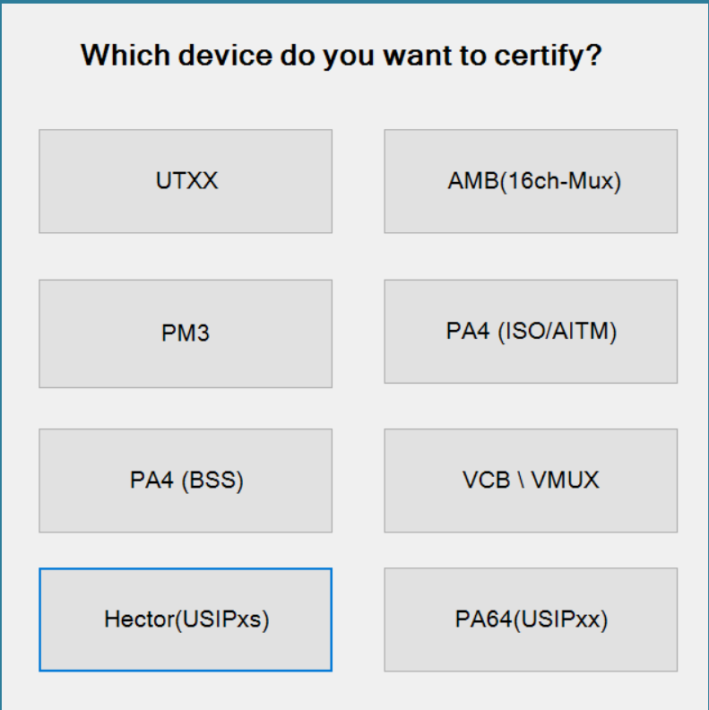

From this point forward, the communication with the electronic cannot be interrupted (e.g. disconnecting the Ethernet cable, turning off the mainframe, etc.). If this should happen, close the Cert.-System software, restart the TCPIPSERV64.exe and start the Cert.-System again.

* Click “Connect”

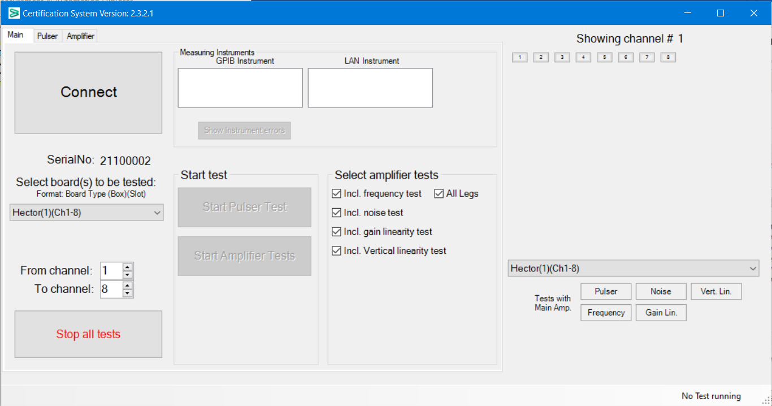

* Ensure that upon successful connection the Main screen will show the “Boxes to be Tested” and a list of the measurement devices (under LAN Instrument).

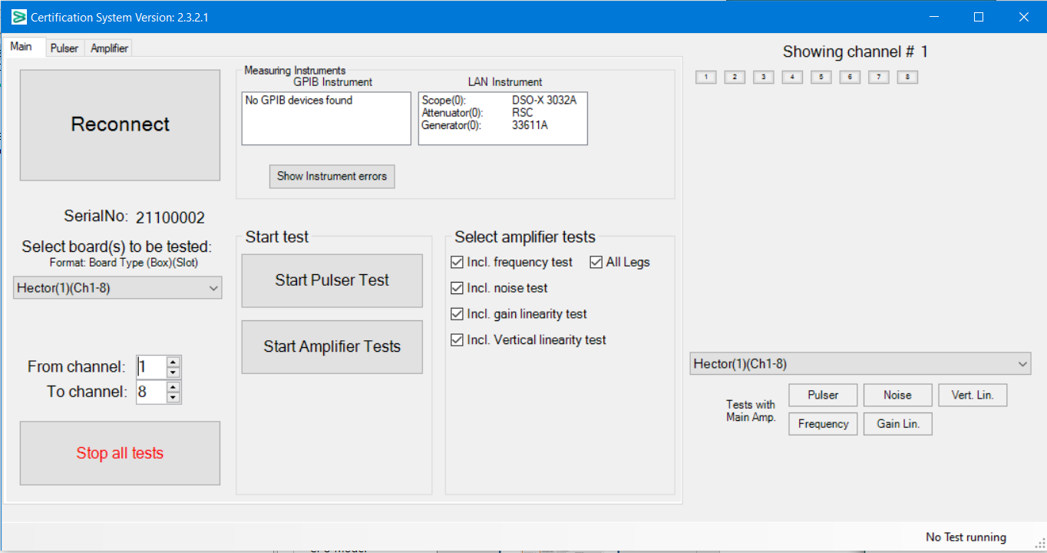

## Certification measurements – Pulser Tests

* On the main window select the box and channels to be certified (area highlighted in orange). The software will automatically measure all the channels that have been selected, but when each box is completed the next one must be selected.
* Click on Start Pulser Test (yellow highlight).



After the next step the pulser will switch on. Be sure the cables are connected correctly to avoid damage to the measurement equipment.

* Connect the cables for the Pulser Test from channel (1 to 64) as shown in the next dialogue and click OK

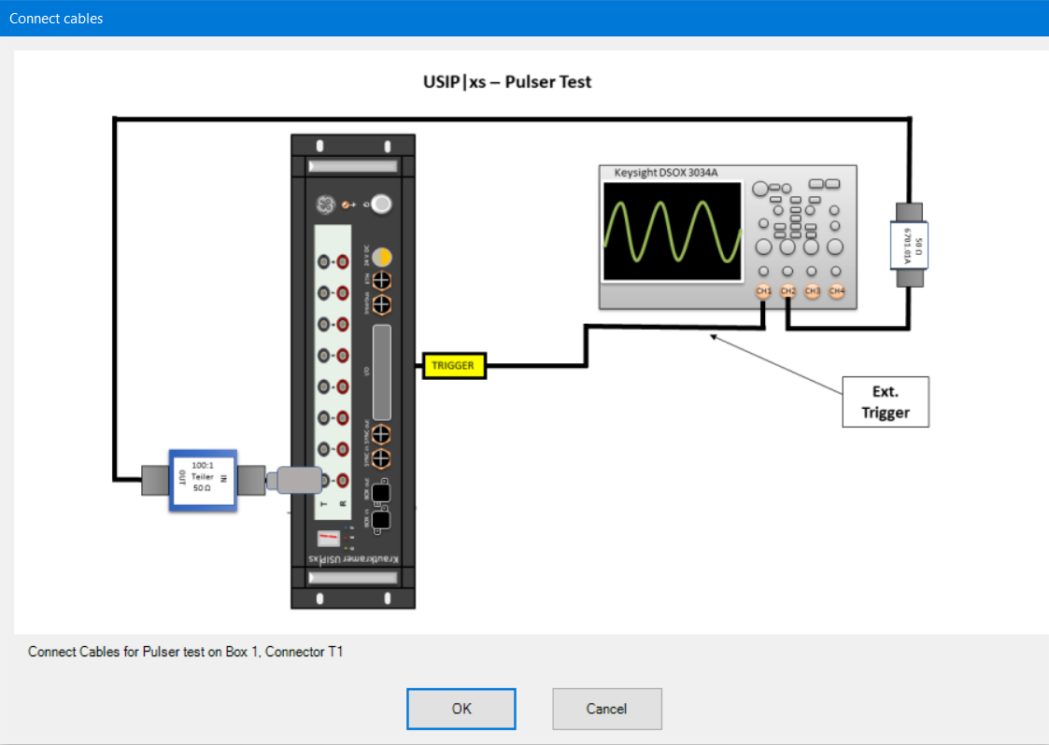

* On the upper left hand side of the main window you can select the Pulser tab to see the measured and tolerance data for each channel.
* In the bottom right hand corner of the screen you see a message “Pulser Test in Slot X, Channel Y running”.
* At the right side of the window a channel number with a yellow background means that the Pulser test was successful but there are other tests that still have to be performed.
* A red background means that one or more values of that channel are outside the tolerance. To see the values of that specific channel, click on the channel number with the red background. All values will be shown on the left table and the measurements outside the tolerance will be highlighted in red.

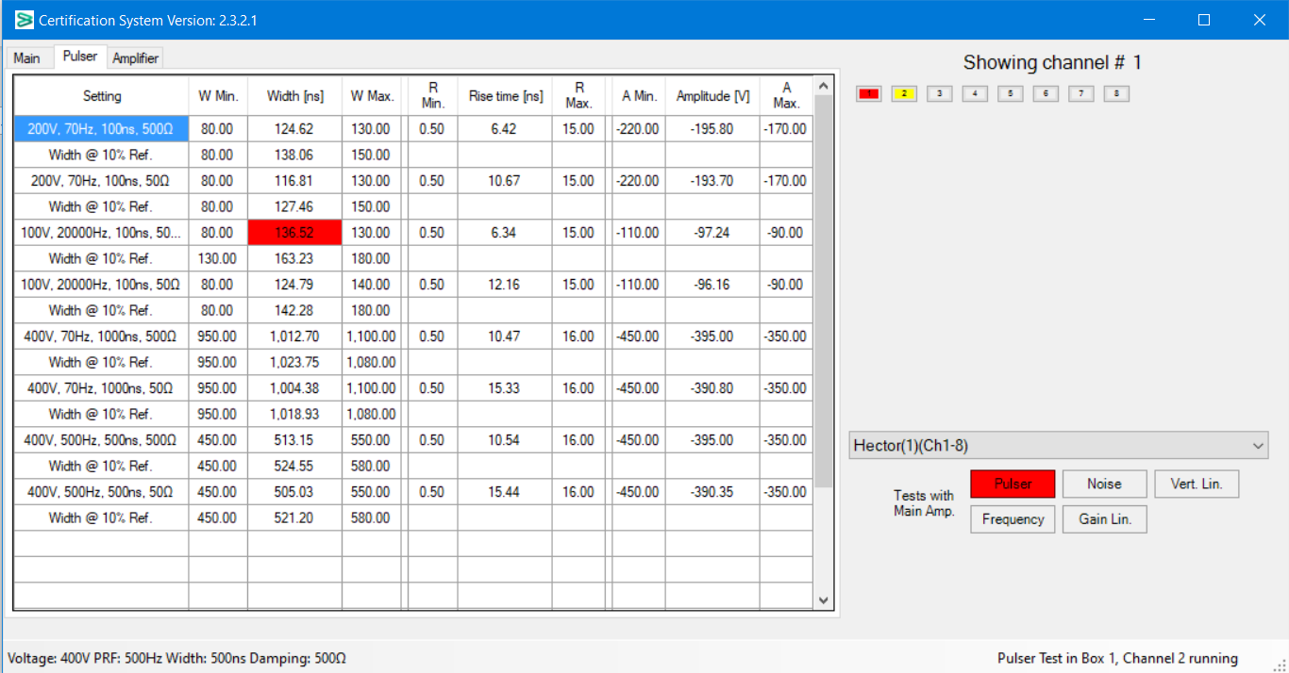

* If any of the tests are outside the tolerance, you can repeat the tests for that channel by selecting the channel number(s) on the Main screen one by one (or in a range if they are sequential). In that case From channel: and To Channel: should both be set to the failed channel number(s).
* If the channels fail again after retesting, the box has to be sent to the service department in Huerth to be repaired.

## 6.3 Certification measurements – Amplifier Tests

* Click on the Main tab and select the box and channels for which the amplifier tests are to be performed. There is also the option of selecting to perform only selected amplifier tests as shown in the orange area of the below diagram.

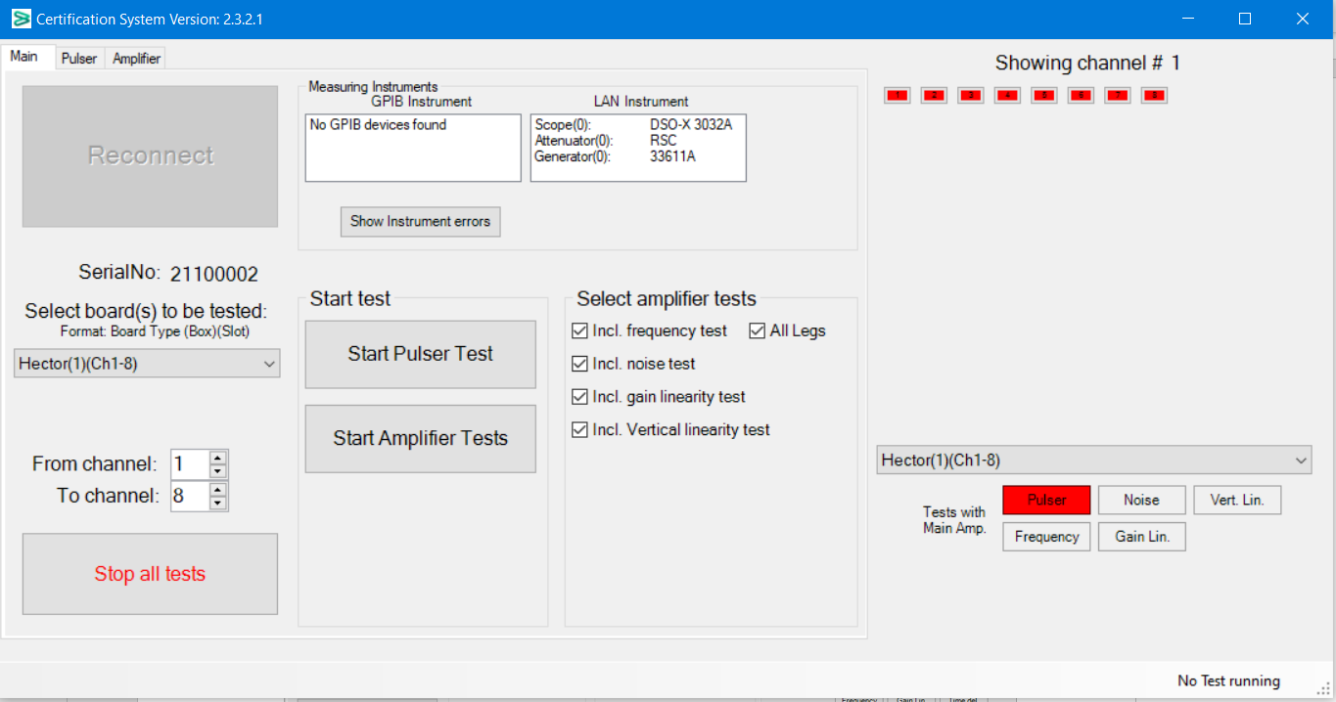

* Ensure that the trigger adapter is connected to the “I/O” connector of the Box being certified. Start the amplifier tests by clicking on the Start Amplifier Tests button.



* Connect the cables for the Amplifier Test as shown in the next dialogue and click OK.

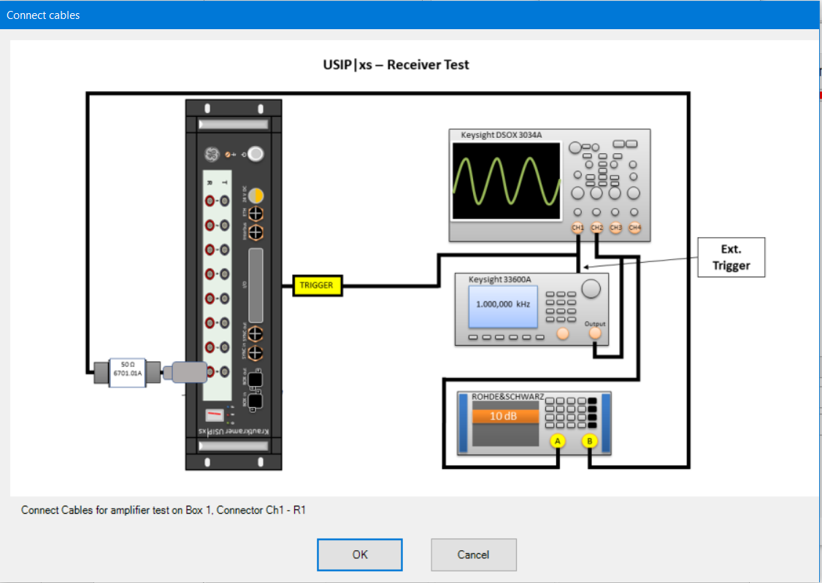

* Follow the connection instructions to measure the remaining channels
* Continue with the amplifier tests on all Boxes present in the TM
* In the bottom right hand corner of the main tab you should see “……….Test in Channel X running”.
* On the upper left hand side of the main window you can select the Amplifier tab to see the measured and tolerance data for each channel.
* At the right side of the window a channel number with a yellow background means that all performed tests on that channel have no error but there are still tests to be performed to finish. A red background means that one or more values of that channel are outside the tolerance. To see the values of that specific channel, click on the channel number with the red background and then click on the test name with the red background at the bottom right side of the window. All values will be shown on the left table and the measurements outside the tolerance will be highlighted in red. If the channel has a green background, all tests were performed and all are inside the tolerances.
* If any of the tests are outside the tolerance, you can repeat the tests for that channel by selecting the channel number(s) on the Main screen one by one. In that case From channel: and To Channel: should both be set to the failed channel number(s).
* If the channels fail again after retesting, the board has to be send to the service department in Huerth to be repaired. The certification of this board can be stopped.

## Certification measurements – Final Steps

* 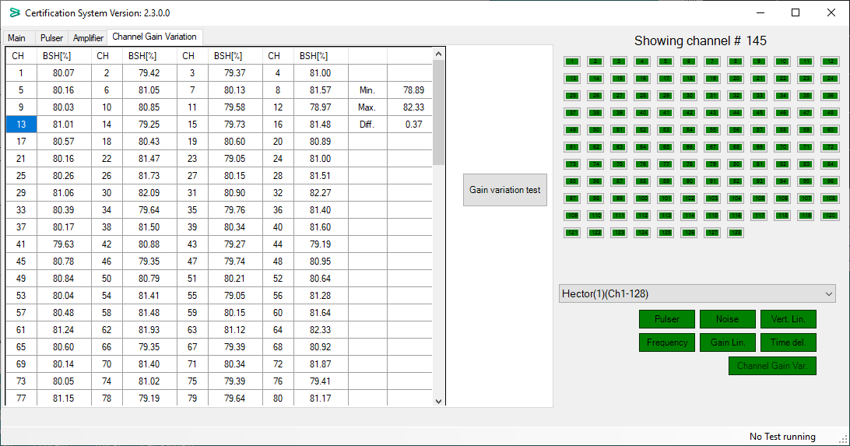When all the tests have been completed, the background of all channels and all buttons should be green.
* Close the program and turn off the mainframe.
* Reconnect the customers testing machines PC and have the operator start the system and confirm that is operational.

# Loading measurement values

* If for any reason you have to interrupt the measurement you can stop the tests by clicking the “Stop all tests” button and close the CertSystem program. To continue the measurement were you left it, type in the same folder name you typed when the interrupted tests were started. The software will ask if you want to import the measured values, select yes and you can continue with the measurements.
* Start the Certification software by double clicking the Cert.System.exe Icon
* Type in your SSO and select the legal entity performing the certification



The SSO will be saved in the database and used to populate the name of the person that performed the certification on the certificate of calibration. It is very important to type a valid SSO.

The selected legal entity will be saved in the database and will be presented on the certificate of calibration. Please select the right one.

* Type the folder name that contains the measurements you want to import.



* Select Hector (USIPxs)



From this point on, the communication with the electronic cannot be interrupted (e.g. disconnecting the Ethernet cable, turning off the mainframe, etc.). If this should happen, close the Cert.-System software, restart the TCPIPSERV64.exe and start the Cert.-System again.

* Click yes on the following window

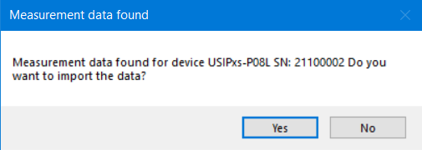

If you click no, all the values will be overwritten with zeros. You will lose all the previous measurements. If you want to start a new measurement but don’t want to erase the previous one, type a new folder name or make a copy of the xml files from the folder Technologies\Cert.-System\Mess_Dat to another folder.

* Click “Connect”



* On the right side of the main window you can see the tests that were already performed. If the channel number has a green background, all tests were performed and there are no errors. If the background is yellow, some tests were done without errors but there are tests still missing to finish the certification. If the background is gray, no tests were done for that channel.

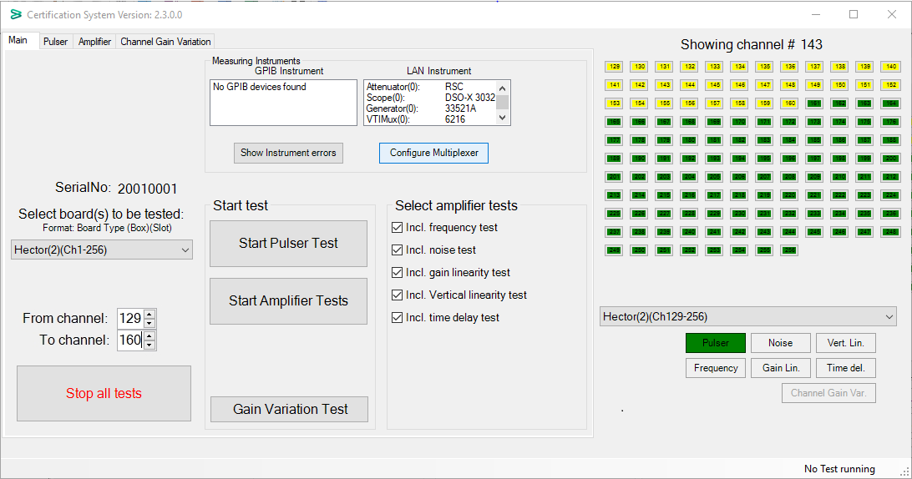

* If needed you can start the Cert-System in “off-line” mode by selecting the XML-Viewer functionality.
* Click “Run as XML _Viewer”



* Follow the same steps as described above to import the XML file and display the measurements without connecting to the electronic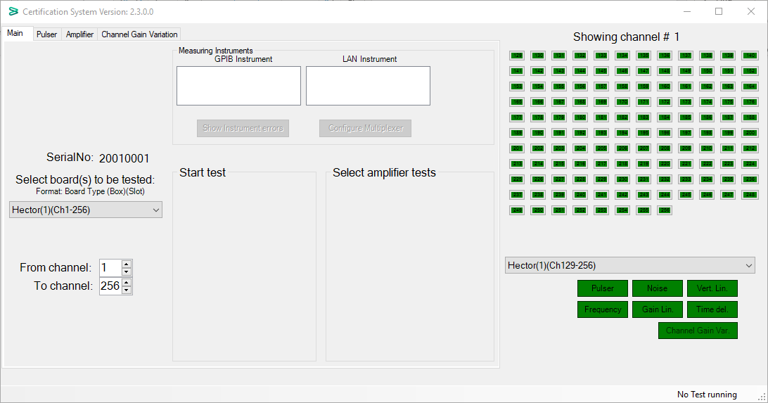

# FAQs

Q The TCPIP Server never connects (T doesn’t turn green)

A Ensure that you ran the restart_tftp.bat as Administrator. If necessary switch off the mainframe and run it again. Ensure the TCPIP addressing is correct in the network adapter settings. Ensure that the laptop’s network adapter is connected to the network switch and that the network switch is powered on.

If still not working on the desktop there is a link to Tftpd64_SE Admin service

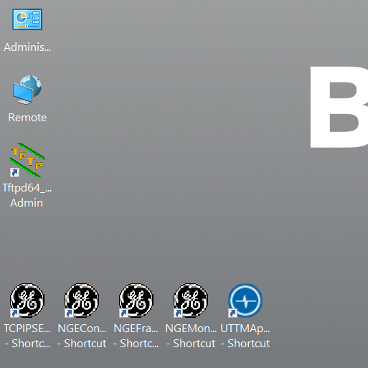

* Clicking on the short cut opens a front end program for the TFTPD service
* The button settings opens the parameter area of the TFTPD Service
* The picture shows all necessary settings for GLOBAL

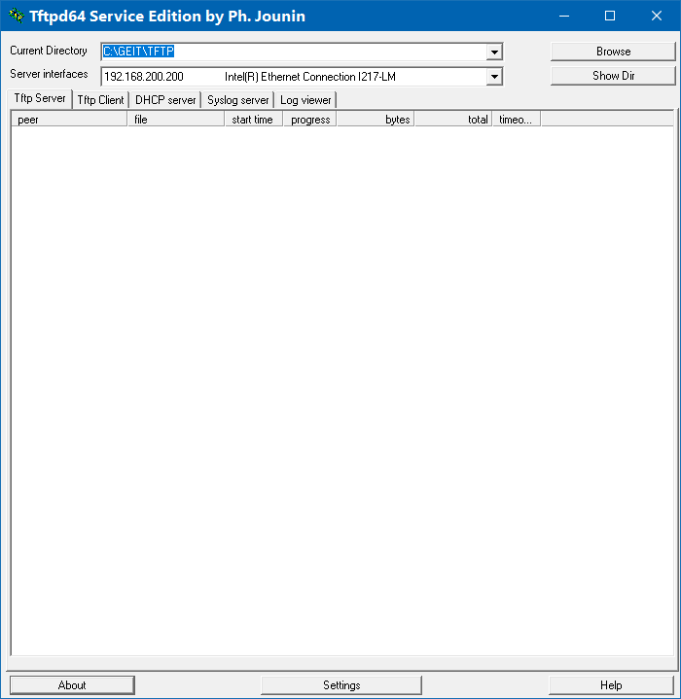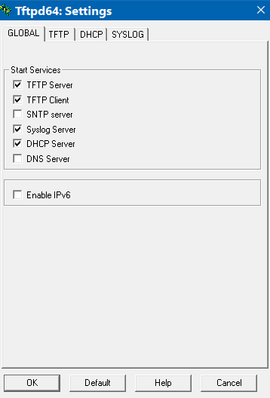

* The pictures show all necessary settings for TFTP and DHCP

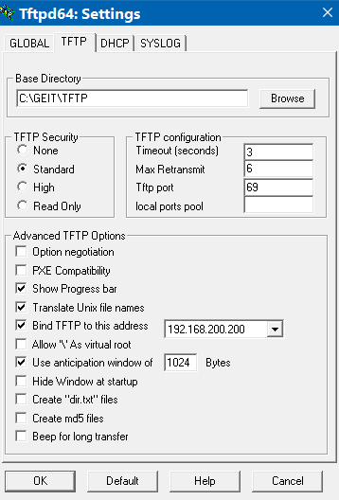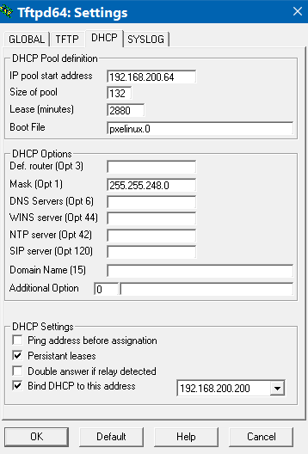

* Also check if the right Hector image is located in TFTP folder

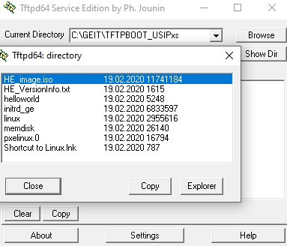

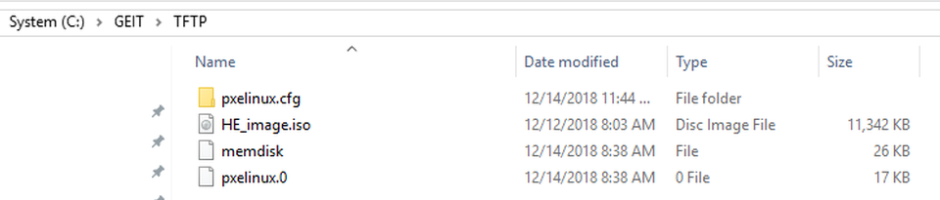

Q What happens when I click the “Stop all tests” button?

* The test currently running is stopped and the measured values for that test in that channel are not saved. The measured values of the tests that already finished will be saved. For example: If you select to run all the amplifier tests and you click the “Stop all tests” during the vertical linearity test, the measured values from the frequency, noise and gain linearity tests are saved but the values of the vertical linearity will be lost.
* The software will show the “No cables connected” message but all the cables are connected.
* Make sure the cables are connected like the picture shows. If the channel of the USIPxs box you are trying to test is damaged (pulser amplitude too low or amplifier not working) it is very probable that you could also see this message.
* I still see the “No cables connected” message
* It is very probable that the multiplexer is not configured. Re-Start the software and configure the multiplexer when prompted.

Q Is there any risk that I might damage the measurement equipment

A If you connect the pulser output directly to the input of the measurement devices without observing the cabling diagrams you could damage the measurement devices or the 100:1 or 50 ohm attenuators. Follow the instructions !

* How can I find out if the trigger adapter is working?
* After you click on the “Start amplifier tests” and see the message asking you to connect the cables, you should see a sinusoidal signal on the second channel of the scope. If you don’t see this signal, the trigger adapter is not connected or is damaged.
* If I have more than one USIPxs box in the mainframe, do I need to connect the trigger adapter to the box that I am testing?
* Yes. You need to connected to the trigger adapter to “I/O” connector of each box.
* What are the IP numbers configured on the laptop?
* The laptop uses two different IP addresses, one to communicate with the USIPxs electronic, and a second one to communicate with the measuring equipment. The way to configure two IP addresses to one LAN connector is as follows:
  + Open the control panel and select “Network and Sharing Center”
  + On the left panel select “Change adapter settings”
  + Right click on the network adapter and select Properties
  + Double click the TCP/IPv4 item on the list
  + Select the option “use the following IP address” if it isn’t already selected
  + Type in the address for the communication with the measuring equipment:
    - IP Address: 192.168.200.235
    - Subnet mask: 255.255.255.0
  + Select “Advanced…”
  + Select “Add…”
  + Type in the address for the communication with the USPxs:
    - IP Address: 192.168.200.200
    - Subnet mask: 255.255.240.0
  + Select “Add” and finally three times “OK”

# References

Electronic copies of published QMS documents are available in SAP:

* USIPxsTechnical Statement (TS_0015556)
* Baker Hughes Declaration of Conformity (146M9098)

# Compliance Timeline

The following timeline is expected from all organizations within scope of this document:

* Full compliance to this process within 90 days of document publication.
* Newly-acquired business entities must comply with the time table requiring Quality Management System assimilation as planned by the Business Development team.

|  |  |
| --- | --- |
|  | BH Quality Management System |
| Title: | < USIPxs Box Certification of Calibration Work Instruction - Cert 2.0> |
| Reference: | <147M2144> |
| Revision: | <-> |
| Application Date: | <14 April 2020> |
| Expiration Date: | <> |
| Author: | <A.Elbasyouny> |
| External References: |  |